Daniel Williamson

Project #4

3/24/17

EE 222

Project Overview

Purpose:

The purpose of this project was implement a linked list ADT in library code. It will be doubly linked but not circular. We are then given a set of unit tests that we test our code against. Once we have all the tests passed, our project is finished.

Approach:

To begin, I needed to understand what the files provided were doing. Thankfully, unlike the previous project, it was rather clear and easy on what was needed to be done. Having just the one make file, made it much more clear. After getting the code to run I started filling in the functions. I started with the creation of the list and nodes, because that was what the unit tests were testing. Once created I simply just moved on down the line. Passing the necessary tests as I went. I did skip list_destroy and list_clear tell the end.

Results:

This is a photo of passing all the unit tests:

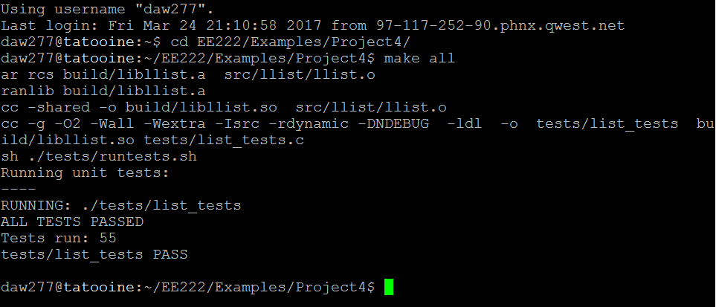

Conclusion:

In conclusion, this was a rather easy lab. Understanding how the links between nodes work was always difficult to visualize. So, writing and drawing it out made it much easier. The most difficult part I ran into was getting those links down correctly. Like in insert_after and insert_before functions. Just making sure the links hooked and re-hooked correctly. To overcome this, like is said earlier, was to draw it all out on a white board.